Dear Parents and Guardians,
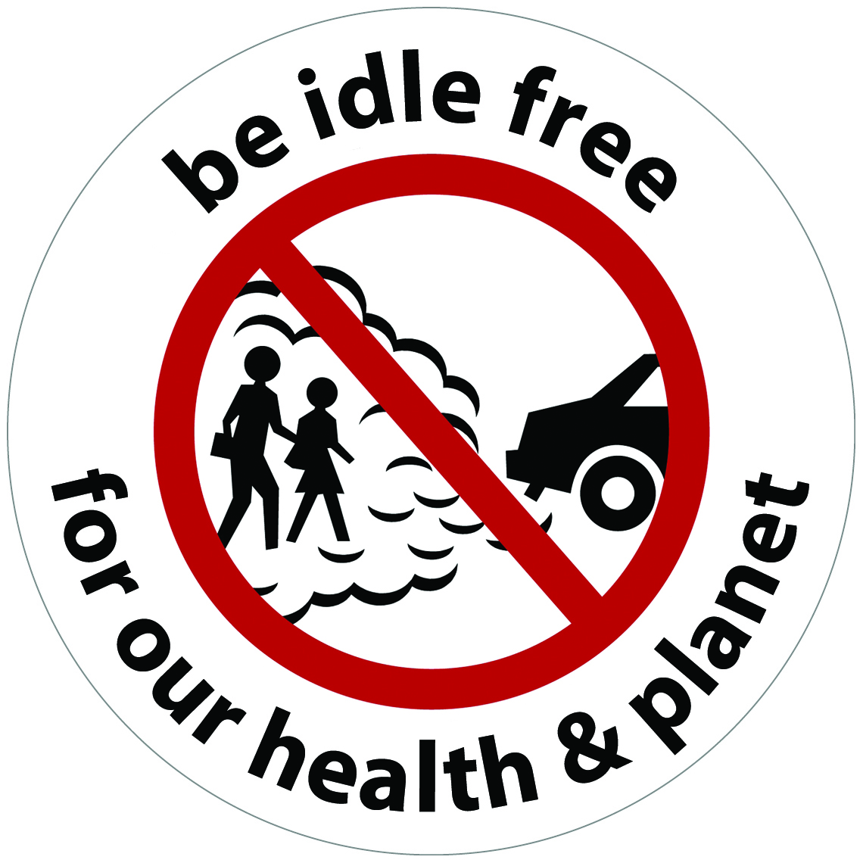
[Insert Name of School] is supporting a vehicle idling reduction effort at our school. All persons operating vehicles at the school should adhere to the following guidelines:

- When waiting for students to be picked up, all engines should be shut off.

- All drivers should turn off engines when they arrive at school and when they expect to be parked for more than 30 seconds.

- If in a line of vehicles away from the school entrance at dismissal, we encourage drivers to stay in their positions with engines shut off, having the student come to them. If drivers must slowly move toward the school entrance, please turn off engines and restart. Note that restarting an engine uses only 10 seconds worth of fuel. Also note that, according to the U.S. DOE, starters are overbuilt and can be started up to 10 times a day with no additional wear: https://anl.app.box.com/s/sfwulyouom8cllqwzqhg07ecc99y5m7z

- If idling is necessary for temperature control, such as for any defrosting issues, or when more than 80 degrees including with frail elderly, infant or pet passengers, please restrict it to no more than a few minutes.

We are implementing this policy to reduce the students’ exposure to air toxics emitted in the exhaust of idling vehicles. Idling vehicles contribute to air pollution and emit air toxins,
which are pollutants known or suspected to cause respiratory illnesses, cancer, or other serious health effects over time. Additionally, idling wastes energy and contributes to climate change.

Included with this letter is a pledge sheet. As part of our Idle Free Schools campaign, we are asking all parents not idle unnecessarily (school bus drivers are expected to adhere to the state’s school bus idling regulation). The pledge can be returned to school with your student.

We encourage you to eliminate unnecessary idling not only at our school but anywhere you are waiting for more than 30 seconds. This simple change will improve the air we breathe, as well reduce carbon dioxide (CO₂) emissions and fossil fuel use that contribute to climate change.

Thank you for your support!

